# TECHNICAL MATHEMATICS P2

# NOVEMBER 2024

# NATIONAL

# SENIOR CERTIFICATE



# GRADE 12

**MARKS: 150**

# TIME: 3 hours

**This question paper consists of 15 pages and a 2-page information sheet.**



|  |  |  |
| --- | --- | --- |
| **INSTRUCTIONS AND INFORMATION**  Read the following instructions carefully before answering the questions. |  |  |

|  |  |  |  |
| --- | --- | --- | --- |
| 1.  2.  3.  4.  5. | This question paper consists of 11 questions.  Answer ALL the questions in the SPECIAL ANSWER BOOK provided.  Clearly show ALL calculations, diagrams, graphs, etc. that you used in determining your answers.  Answers only will NOT necessarily be awarded full marks.  If necessary, round off answers to TWO decimal places, unless stated otherwise. |  |  |

|  |  |  |  |
| --- | --- | --- | --- |
| 6.  7.  8.  9. | Diagrams are NOT necessarily drawn to scale.  You may use an approved scientific calculator (non-programmable and  non-graphical), unless stated otherwise.  An information sheet with formulae is included at the end of the question paper.  Write neatly and legibly. |  |  |

|  |  |  |
| --- | --- | --- |
| **QUESTION 1** |  |  |

|  |  |  |
| --- | --- | --- |
| The diagram below shows ABC with vertices ,  and .  CA is produced to form the angle of inclination, , with the positive *x*-axis.  M is the midpoint of CA. Nov |  |  |
|  |  |  |

|  |  |  |  |
| --- | --- | --- | --- |
| 1.1 | Determine the gradient of AC. |  | (2) |

|  |  |  |  |
| --- | --- | --- | --- |
| 1.2 | Hence, determine the size of angle . |  | (2) |

|  |  |  |  |
| --- | --- | --- | --- |
| 1.3 | Determine the length of BC. |  | (2) |

|  |  |  |  |
| --- | --- | --- | --- |
| 1.4 | Determine the coordinates of M. |  | (2) |

|  |  |  |  |
| --- | --- | --- | --- |
| 1.5 | Determine the equation of the line through M, perpendicular to CA, in the form *y* = … |  | (4) |
|  |  |  | **[12]** |

|  |  |  |
| --- | --- | --- |
| **QUESTION 2** |  |  |

|  |  |  |  |
| --- | --- | --- | --- |
| 2.1 | In the diagram below, O is the centre of the circle defined by  PR is a tangent to the circle at point P.  Point S is an *x*-intercept of the circle.  Point R is the *y*-intercept of line PR. |  |  |

|  |  |  |  |  |
| --- | --- | --- | --- | --- |
|  | 2.1.1 | Determine the equation of the circle. |  | (2) |

|  |  |  |  |  |
| --- | --- | --- | --- | --- |
|  | 2.1.2 | Write down the coordinates of S. |  | (2) |

|  |  |  |  |  |
| --- | --- | --- | --- | --- |
|  | 2.1.3 | Determine the equation of the tangent in the form *y* = … |  | (4) |

|  |  |  |  |  |
| --- | --- | --- | --- | --- |
|  | 2.1.4 | Write down the *y*-coordinate of point R. |  | (1) |

|  |  |  |  |
| --- | --- | --- | --- |
| 2.2 | Given: |  |  |

|  |  |  |  |  |
| --- | --- | --- | --- | --- |
|  | 2.2.1 | Express the equation in the form |  | (1) |

|  |  |  |  |  |
| --- | --- | --- | --- | --- |
|  | 2.2.2 | Hence, sketch the graph of the ellipse. |  | (2) |
|  |  |  |  | **[12]** |

|  |  |  |
| --- | --- | --- |
| **QUESTION 3** |  |  |

|  |  |  |  |
| --- | --- | --- | --- |
| 3.1 | Given:  rad and  Use a calculator to determine the following: |  |  |

|  |  |  |  |  |
| --- | --- | --- | --- | --- |
|  | 3.1.1 | Convert  rad to degrees. |  | (1) |

|  |  |  |  |  |
| --- | --- | --- | --- | --- |
|  | 3.1.2 |  |  | (2) |

|  |  |  |  |  |
| --- | --- | --- | --- | --- |
|  | 3.1.3 |  |  | (2) |

|  |  |  |  |
| --- | --- | --- | --- |
| 3.2 | In the diagram below,  is a point in a Cartesian plane.  and  is an angle of inclination. |  |  |

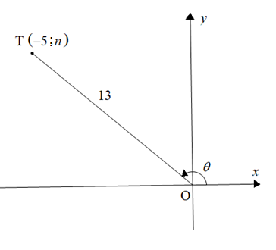

|  |  |  |  |
| --- | --- | --- | --- |
|  | **Without using a calculator**,determine the value of the following: |  |  |

|  |  |  |  |  |
| --- | --- | --- | --- | --- |
|  | 3.2.1 |  |  | (1) |

|  |  |  |  |  |
| --- | --- | --- | --- | --- |
|  | 3.2.2 |  |  | (4) |

|  |  |  |  |
| --- | --- | --- | --- |
| 3.3 | Determine the value(s) of *x* if  for |  | (4) |
|  |  |  | **[14]** |

|  |  |  |
| --- | --- | --- |
| **QUESTION 4** |  |  |

|  |  |  |  |
| --- | --- | --- | --- |
| 4.1 | Simplify the following: |  |  |

|  |  |  |  |  |
| --- | --- | --- | --- | --- |
|  | 4.1.1 |  |  | (1) |

|  |  |  |  |  |
| --- | --- | --- | --- | --- |
|  | 4.1.2 |  |  | (1) |

|  |  |  |  |  |
| --- | --- | --- | --- | --- |
|  | 4.1.3 |  |  | (6) |

|  |  |  |  |
| --- | --- | --- | --- |
| 4.2 | Answer the following questions: |  |  |

|  |  |  |  |  |
| --- | --- | --- | --- | --- |
|  | 4.2.1 | Complete the identity: |  | (1) |

|  |  |  |  |  |  |
| --- | --- | --- | --- | --- | --- |
|  | 4.2.2 | Hence, prove that |  | (4) | |
|  |  |  |  | | **[13]** |

|  |  |  |
| --- | --- | --- |
| **QUESTION 5** |  |  |

|  |  |  |
| --- | --- | --- |
| Given the functions defined by  and  for |  |  |

|  |  |  |  |
| --- | --- | --- | --- |
| 5.1 | Sketch the graphs of *f* and g on the same set of axes on the grid provided. Clearly indicate ALL the asymptotes, intercepts with the axes and turning points. |  | (6) |

|  |  |  |  |
| --- | --- | --- | --- |
| 5.2 | Use your graphs to write down the following: |  |  |

|  |  |  |  |  |
| --- | --- | --- | --- | --- |
|  | 5.2.1 | The period of *g* |  | (1) |

|  |  |  |  |  |
| --- | --- | --- | --- | --- |
|  | 5.2.2 | TWO values of *x* for which |  | (2) |

|  |  |  |  |  |
| --- | --- | --- | --- | --- |
|  | 5.2.3 | The amplitude of |  | (1) |

|  |  |  |  |  |
| --- | --- | --- | --- | --- |
|  | 5.2.4 | The resultant (new) equation *h*, if:   * The period of *g* is halved, and * The range is |  | (2) |

|  |  |  |  |
| --- | --- | --- | --- |
|  |  |  | **[12]** |

|  |  |  |
| --- | --- | --- |
| **QUESTION 6** |  |  |

|  |  |  |
| --- | --- | --- |
| In the diagram below, T, R and N are points in the same horizontal plane.    The angle of elevation of P from R is .  and |  |  |

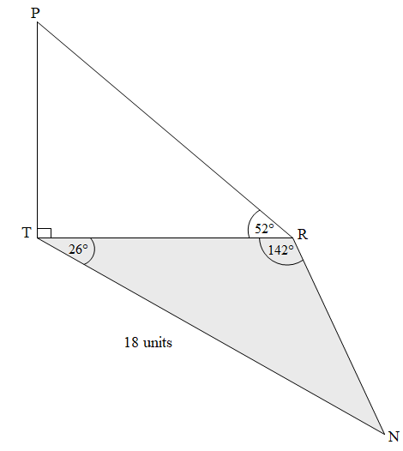

|  |  |  |  |
| --- | --- | --- | --- |
| 6.1 | Write down the size of angle N. |  | (1) |

|  |  |  |  |
| --- | --- | --- | --- |
| 6.2 | Determine the length of TR. |  | (3) |

|  |  |  |  |
| --- | --- | --- | --- |
| 6.3 | Hence, determine the length of PT. |  | (2) |

|  |  |  |  |
| --- | --- | --- | --- |
| 6.4 | Determine: |  | (5) |
|  |  |  | **[11]** |

|  |  |  |
| --- | --- | --- |
| **Give reasons for your statements in QUESTIONS 7, 8 and 9.** |  |  |

|  |  |  |
| --- | --- | --- |
| **QUESTION 7** |  |  |

|  |  |  |
| --- | --- | --- |
| In the diagram below, O is the centre of circle ABCD.  AOM is a straight line.  M is the midpoint of chord DC. |  |  |

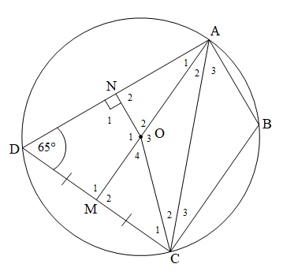

|  |  |  |  |
| --- | --- | --- | --- |
| 7.1 | Write down the reason why |  | (1) |

|  |  |  |  |
| --- | --- | --- | --- |
| 7.2 | Hence, write down the reason why DMON is a cyclic quadrilateral. |  | (1) |

|  |  |  |  |
| --- | --- | --- | --- |
| 7.3 | Complete the following table: |  |  |

|  |  |  |  |  |
| --- | --- | --- | --- | --- |
|  | **STATEMENT** | **REASON** |  |  |
|  |  | Opposite ∠s of cyclic quad |  | (1) |
|  |  | Opposite ∠s of cyclic quad |  | (1) |
|  | DN = … | … |  | (2) |

|  |  |  |  |
| --- | --- | --- | --- |
| 7.4 | Prove that stating reasons. |  | (3) |

|  |  |  |  |
| --- | --- | --- | --- |
| 7.5 | Show, with reasons, that AOCB is not a cyclic quadrilateral. |  | (3) |
|  |  |  | **[12]** |

|  |  |  |
| --- | --- | --- |
| **QUESTION 8** |  |  |

|  |  |  |  |
| --- | --- | --- | --- |
| 8.1 | In the diagram below, O is the centre of circle PSTRN.  Chords TR and SN are extended to meet at M such that NM = NR.  and |  |  |

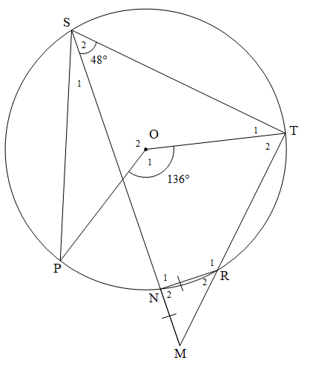

|  |  |  |  |
| --- | --- | --- | --- |
|  | Determine, stating reasons, the size of EACH of the following angles: |  |  |

|  |  |  |  |  |
| --- | --- | --- | --- | --- |
|  | 8.1.1 |  |  | (3) |

|  |  |  |  |  |
| --- | --- | --- | --- | --- |
|  | 8.1.2 |  |  | (6) |

|  |  |  |  |
| --- | --- | --- | --- |
| 8.2 | In the diagram below, PT is a tangent to circle PQR at P.    SR is drawn so that RS || PT |  |  |

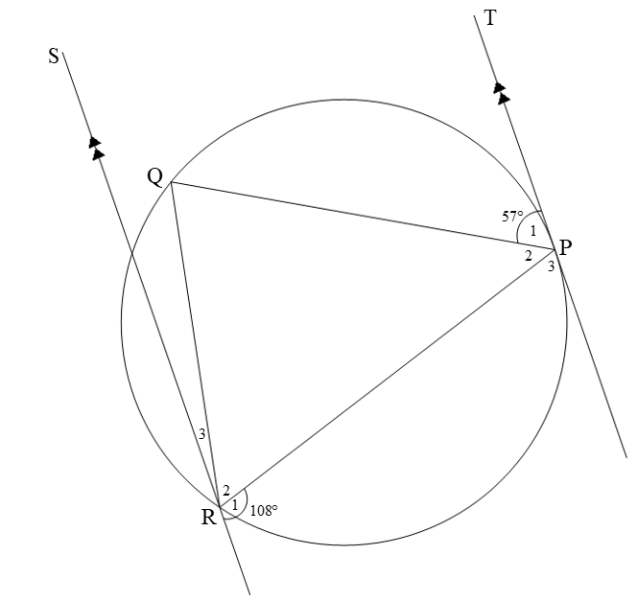

|  |  |  |  |  |
| --- | --- | --- | --- | --- |
|  | 8.2.1 | Determine, stating reasons, the size of . |  | (2) |

|  |  |  |  |  |
| --- | --- | --- | --- | --- |
|  | 8.2.2 | Show, stating reasons, that |  | (4) |
|  |  | |  | **[15]** |

|  |  |  |
| --- | --- | --- |
| **QUESTION 9** |  |  |

|  |  |  |
| --- | --- | --- |
| In ΔRST below, P is a point on RS. V and W are points on RT so that PV || SW.  PT and SW intersect at Q.  W is the midpoint of VT.  PS = 9 cm, WT = 6 cm, RV = 2 cm and QW = 1,5 cm |  |  |

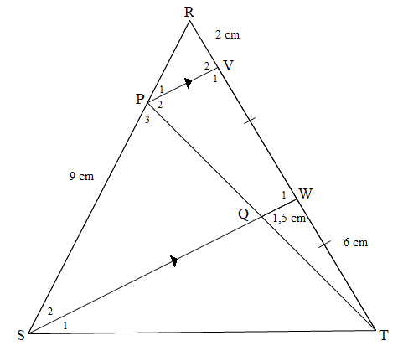

|  |  |  |  |
| --- | --- | --- | --- |
| 9.1 | Write down the length of VW. |  | (1) |

|  |  |  |  |
| --- | --- | --- | --- |
| 9.2 | Hence, determine the length of RP, stating reasons. |  | (3) |

|  |  |  |  |
| --- | --- | --- | --- |
| 9.3 | Write down the length of PV, stating a reason. |  | (2) |

|  |  |  |  |
| --- | --- | --- | --- |
| 9.4 | Prove that Δ RPV ||| Δ RSW, stating reasons. |  | (3) |

|  |  |  |  |
| --- | --- | --- | --- |
| 9.5 | Hence, determine the length of SW. |  | (2) |
|  |  |  | **[11]** |

|  |  |  |
| --- | --- | --- |
| **QUESTION 10** |  |  |

|  |  |  |  |
| --- | --- | --- | --- |
| 10.1 | The picture and diagram below show a bicycle wheel. The diagram models the circular path of the rotating wheel.   * The radius of the wheel is 40 cm. * AB represents a chord of the circle with centre O. * *h* is the minor height of the segment in relation to chord AB. |  |  |

|  |  |
| --- | --- |
| Vintage Bicycle Wheel Isolated On White Front wheel of a vintage bicycle, isolated on white. Clipping path included (inner edges) bike wheel stock pictures, royalty-free photos & images |  |

|  |  |  |
| --- | --- | --- |
| If the wheel rotates at 48 revolutions per minute, answer the following questions: |  |  |

|  |  |  |  |  |
| --- | --- | --- | --- | --- |
|  | 10.1.1 | Convert the rotation frequency of 48 revolutions per minute to revolutions per second. |  | (1) |

|  |  |  |  |  |
| --- | --- | --- | --- | --- |
|  | 10.1.2 | Write down the length of the radius of the wheel in metres. |  | (1) |

|  |  |  |  |  |
| --- | --- | --- | --- | --- |
|  | 10.1.3 | Hence, write down the length of the diameter in metres. |  | (1) |

|  |  |  |  |  |
| --- | --- | --- | --- | --- |
|  | 10.1.4 | Hence, determine the circumferential velocity of a point on the circumference of the wheel, in metres per second. |  | (3) |

|  |  |  |  |  |
| --- | --- | --- | --- | --- |
|  | 10.1.5 | If it is further given that *h* = 8 cm, determine the length of AB in cm. |  | (4) |

|  |  |  |  |
| --- | --- | --- | --- |
| 10.2 | The picture below shows 3 meshed gears. The diagram below the picture models this scenario.   * The driver gear (centre A) has a radius of 10 cm, while the smaller gears  (centre B and centre C) have radii of 8 cm and 6 cm respectively. * The gears touch at points D, E and F. * Points D, E and F lie on the sides of * The shaded sector GBH has a central angle of * Arc DF subtends a central angle of |  |  |

|  |
| --- |
| 3 Gear: Over 14,136 Royalty-Free Licensable Stock Photos ... |
|  |

|  |  |  |  |  |
| --- | --- | --- | --- | --- |
|  | 10.2.1 | Convert  to radians. |  | (1) |

|  |  |  |  |  |
| --- | --- | --- | --- | --- |
|  | 10.2.2 | Hence, calculate the area of the shaded sector GBH. |  | (3) |

|  |  |  |  |  |
| --- | --- | --- | --- | --- |
|  | 10.2.3 | Write down the length of AC |  | (1) |

|  |  |  |  |  |
| --- | --- | --- | --- | --- |
|  | 10.2.4 | Determine the length of arc DF. |  | (5) |
|  |  |  |  | **[20]** |

|  |  |  |
| --- | --- | --- |
| **QUESTION 11** |  |  |

|  |  |  |  |  |  |
| --- | --- | --- | --- | --- | --- |
| 11.1 | | The diagram below models the picture of a wall with a shaded irregular plastered section.   * The dimensions of the wall: length = 3 m and width = 2 m * The irregular plastered section has a straight side of *x* cm, divided into 4 equal parts, as shown. * The ordinates dividing these parts are 1,2 m; 1,15 m; 1,25 m; 1,1 m and 0,9 m respectively. * The length from the floor to the 0,9 m ordinate is equal to 1,2 m. |  | |  |
| How To Hard Plaster a Brick Wall - Bunnings New Zealand | | |
|  | | |

|  |  |  |  |  |
| --- | --- | --- | --- | --- |
|  | 11.1.1 | Determine the numerical value of *x* |  | (1) |

|  |  |  |  |  |
| --- | --- | --- | --- | --- |
|  | 11.1.2 | Hence, determine the width of each equal part. |  | (1) |

|  |  |  |  |  |
| --- | --- | --- | --- | --- |
|  | 11.1.3 | Hence, determine the area of the shadedirregular plastered section. |  | (3) |

|  |  |  |  |  |
| --- | --- | --- | --- | --- |
|  | 11.1.4 | Determine whether R1 700 will be sufficient to plaster the rest of the wall, if the cost for plastering, including material and labour, is R300 per square metre. |  | (5) |

|  |  |  |  |
| --- | --- | --- | --- |
| 11.2 | The picture below shows a pillar cap that is placed on top of pillars of boundary walls. The diagram alongside models the pillar cap with the following dimensions:   * The pyramid section has a square base of lengths 60 cm by 60 cm and a slant height of 50 cm. * The rectangular prism section has the same square base dimensions as the pyramid and a height of 10 cm. * *x* cm represents the vertical height of the pyramid section. |  |  |

|  |  |
| --- | --- |
| Pillar cap  Pier Cap Natural 300 x 300mm | Totem Timber |  |

|  |
| --- |
| **The following formulae may be used:**  **Surface area of rectangular prism**  **Volume of rectangular prism**  **Volume of pyramid** |

|  |  |  |  |  |
| --- | --- | --- | --- | --- |
|  | 11.2.1 | Determine the surface area of the rectangular prism section of the pillar cap. |  | (3) |

|  |  |  |  |  |
| --- | --- | --- | --- | --- |
|  | 11.2.2 | Determine the value of *x* , the vertical height of the pyramid. |  | (2) |

|  |  |  |  |  |
| --- | --- | --- | --- | --- |
|  | 11.2.3 | Determine the total volume of ONE pillar cap. |  | (3) |
|  |  |  |  | **[18]** |
|  |  |  |  |  |
|  |  | **TOTAL:** |  | **150** |

**INFORMATION SHEET: TECHNICAL MATHEMATICS**

   

, 

   





 , 

, 

 , 

M





InΔABC: 



  



Angular velocity  where *n* = rotation frequency

Angular velocity  where *n* = rotation frequency

Circumferential velocity where *D* = diameter and *n* = rotation frequency

Circumferential velocity  where = angular velocity and *r* = radius

Arc length  where *r* = radius and  = central angle in radians

Area of a sector  where *r* = radius, *s* = arc length

Area of a sector  where *r* = radius and  = central angle in radians

 where *h* = height of segment, *d* = diameter of circle   
 and *x* = length of chord

 where width of equal parts, 

 ordinate and *n* = number of ordinates

**OR**

 where width of equal parts,  ordinate

and *n* = number of ordinates